Changes:

We will need a documentation of all the work done, so that we know where changes have been made what exactly has been made -> we need to be able to adapt your work afterwards.

Below is explained what changes we would like to have implemented.

**Topic 1** is the search function on the landing page.

**Topic 2** are changes on the “new order emails” to restaurants

**Topic 3** considering the Restaurant opening hours in the **“PI Woocommerce order date time and type” plugin**

**Topic 1: Search function on landing page**

Currently our landing page looks like this:

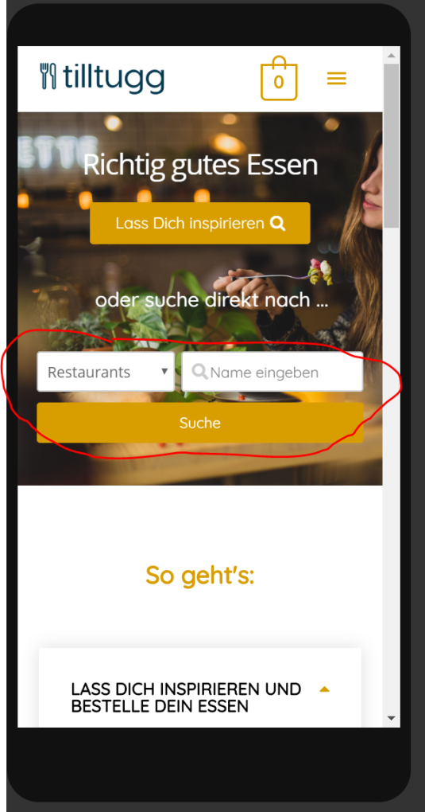

We would like you to change the red marked area as follows:

1. The left drop down shall have three option “Cuisine” (default!), “Nutrition” and the last one shall be “Restaurants”
2. The right drop down shall show depend on the left drop down:
   1. If left is “Cuisine”, right drop down shall show all categories that I wrote in CAPITAL LETTERS (ASIATISCH; BURGER & CO; INDISCH; INSPIRE ME; ITALIENISCH; SOUPS & SALADS; SUSHI; THAI)
   2. If left is “Nutrition”, right drop down shall show all categories that I wrote with first letter capital (Bio; CH-Meat; High Protein; Local; Sweet delights – no regrets; Vegan; Vegetarisch; Vitamins)

🡪 can we have for both a and b: default entry of the right drop down shall be “Bitte wählen” (which means “Please choose”). When the user clicks on “Bitte wählen”, the drop down shall open, with all relevant categories. When he clicks on one category, he shall be directly get to the shop site with the products of the relevant category. 🡪 if this is possible, please remove the search button completely (“Suche”, marked)

* 1. If left is “Restaurants”, right shall remain as it is currently, i.e. the search field where user can search for restaurants. However, here as well I realised we do not need the search button (“Suche” button), as we have the auto-complete.

Not sure how you implement a) and b). Please let me know in case we need to make Subcategories.

Again, we need a documentation to see where categories of both drop downs can be changed, added, deleted, and where the default settings can be changed.

**Topic 2: changes to new order emails to restaurants:**

New order emails are sent in plain text to restaurants. We used advanced notifications plugin to being able to send order email only to the relevant restaurant.

Can you please do the following changes:

* Change width of the plain text new order email, which goes to restaurants, to 50 mm
* Add the information “Abholdatum” and “Abholzeit” to the plain text new order email for the restaurants (just for information: Abholdatum and Abholzeit is provided in the order confirmation email which goes to the client as html email). Abholdatum and Abholzeit  are originally called either pick up date (time) or delivery date (time) and come from the **“PI Woocommerce order date time and type” plugin**

Please document where you made the changes and how. Thank you

**Topic 3 considering the Restaurant opening hours in the “PI Woocommerce order date time and type” plugin:**

On the site “Deine Bestellung” (which is cart plus payment site) the user is being asked when he wants to pick up the dish (date and time), which comes from the plugin “**PI Woocommerce order date time and type”.** Is it possible that you consider the restaurants opening hours (defined in the restaurants section) for the pick up dates and times of the individual products/ restaurants?